**Block Diagram for Pitch Channel:**

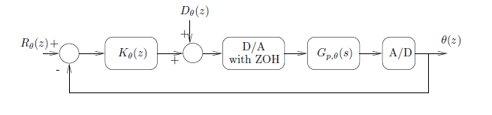

$$G_{p,θ\left(s\right)}= \frac{θ\left(s\right)}{V_{p}\left(s\right)}=\frac{37.2021}{s^{2}+0.2830s+2.7452}$$

**Block Diagram for Yaw Channel:**

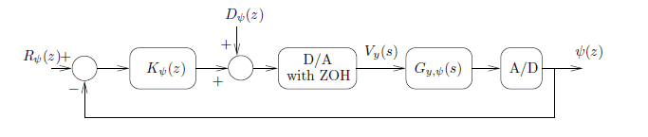

$$G_{p,φ\left(s\right)}= \frac{φ\left(s\right)}{V_{y}\left(s\right)}=\frac{7.461}{s(s+0.2701)}$$

**Controller Specifications:**

1. Percentage of overshoot for step reference input ≤ 20%

2. Settling time of step response ≤ 18 sec

3. Rise time of step response ≤ 3 sec

4. Steady-state error for step reference input = 0

5. Steady-state output in response to step disturbance = 0

**Overall Closed-loop System:**

